**CB[1] – Decomposition and Using Software Cortland Watson**

Part I – Individual Quiz (Before Class)

Part II – Group Quiz (During Class)

1. What are the structural factors for a one-way CB design (2 pts)?

Estimated effect degrees of freedom

1. How do you calculate the Estimated effect and degrees of freedom for the Blocks factor for a Complete Block Design (2 pts)?

Benchmark grand avg 1

Blocks B1 avg – G avg # blocks -1

Treatments Tr avg – G avg # treatments – 1

Residual error obs – fit (# blocks – 1) * (# treatments – 1)

Fit = block avg + treatment avg – grand average

**End of Part I**

1. Were you in class on time (2 pts)?

Yes

1. Do decomposition of the data and an ANOVA table for the factors in the Auditor Training data (6 pts)

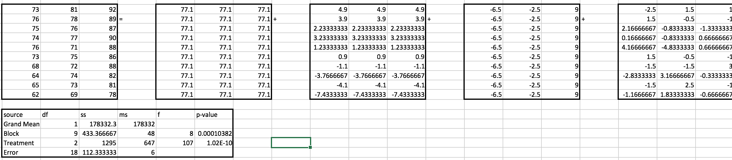

1. Get an ANOVA table using for the Auditor Training data and evaluate the results. Also, check the requirements of the residuals being normally distributed and that the variances are equal. (8 pts).

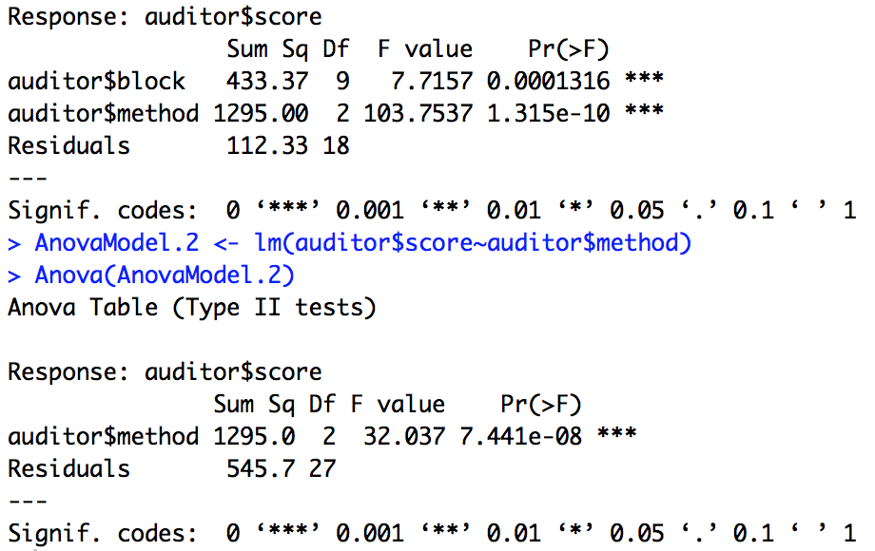

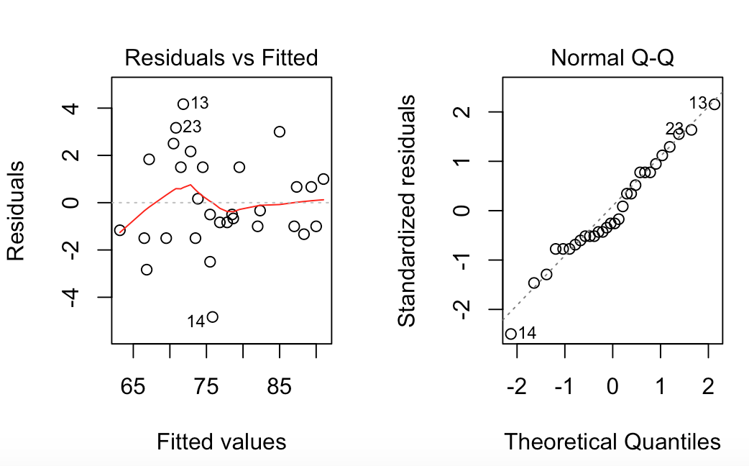

1. Do a basic factorial with just the method and without the block and compare results (3 points)

